11.1 Acids and bases
Name: ____________________ Class: ____________________ Due date:
5. The graph shows how the pH changes as an acid is added to an alkali.
Which letter represents the area of the graph where both acid and salt are present?
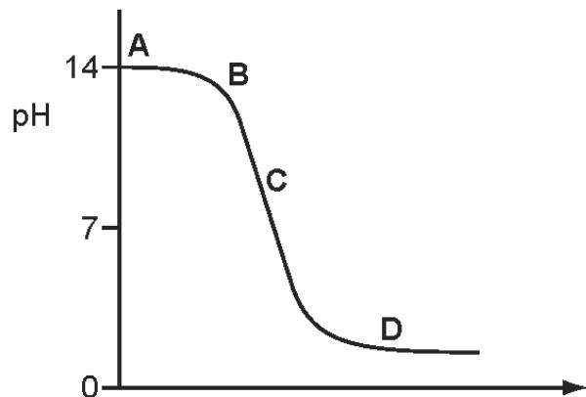
Barium hydroxide is an alkali. It reacts with hydrochloric acid.
How does the pH of the hydrochloric acid change as an excess of aqueous barium hydroxide is added?
A The pH decreases from 14 and becomes constant at 7.
B The pH decreases from 14 to about 1.
C The pH increases from 1 and becomes constant at 7.
D The pH increases from 1 to about 14.

Ant stings hurt because of the methanoic acid produced by the ant.
Which substance could, most safely, be used to neutralise the acid?
 | substance | pH
A | baking soda | 8
B | car battery acid | 1
C | lemon juice | 3
D | oven cleaner | 14

Different plants grow best under different pH conditions.
Which plant grows best in alkaline soil?
 | plant | grows best in soil at pH
A | cabbage | 6-8
B | potato | 4-7
C | strawberry | 5-7
D | wheat | 6-7

Which substance is the most acidic?
 | substance | pH
A | calcium hydroxide | 12
B | lemon juice | 4
C | milk | 6
D | washing up liquid | 8

The graph shows how the pH of soil in a field changes over time.
At which point was the soil neutral?
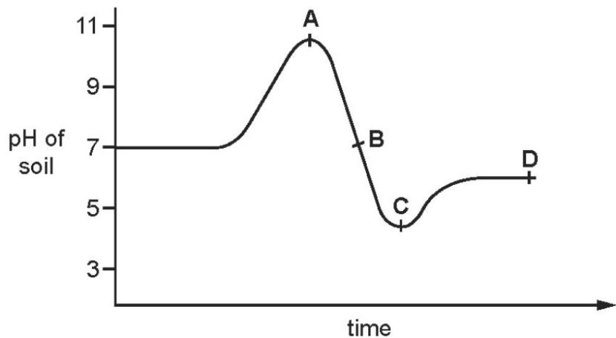

A sting from insect X has a pH of 6 and a sting from insect Y has a pH of 8. The table shows the pH of four substances.
substance | pH
hydrochloric acid | 1
sodium hydrogen carbonate | 8
sodium hydroxide | 14
vinegar | 5
Which substances are used to treat the two stings?
 | X | Y
A | hydrochloric acid | sodium hydroxide
B | sodium hydrogen carbonate | vinegar
C | sodium hydroxide | hydrochloric acid
D | vinegar | sodium hydrogen carbonate

Which solution has the lowest pH?
A $0.1mol/{dm}^{3}$ ammonia solution
B $0.1mol/{dm}^{3}$ ethanoic acid
C $0.1mol/{dm}^{3}$ lithium hydroxide
D $0.1mol/{dm}^{3}$ nitric acid

Carbonic acid is a weak acid formed when carbon dioxide dissolves in water.
What is the pH of the solution?
A 1 B 5 C 7 D 9

Ammonia is a compound which only contains the elements nitrogen and hydrogen.
It is a weak base.
Define the term base.
..................................................................................................................................
..................................................................................................................................
Given aqueous solutions of ammonia and sodium hydroxide, both having a concentration of $0.1mol/{dm}^{3}$ , how could you show that ammonia is the weaker base?
..................................................................................................................................
..................................................................................................................................[2]

